Multiple-choice section – choose the correct answer

Question 1 [5.1]

To find *q* from 6q + 3 = 15 you need to:

A divide 15 by 6, then subtract 3 from the answer

B add 3 to 15, then subtract 3 from the answer

C subtract 3 from 15, then divide the answer by 6

D divide 15 by 3, then subtract the answer by 6

Question 2 [5.2]

There are 32 students in a Year 9 Maths class. There are 6 more girls than boys in the class. If the number of boys is *x*, an equation for the total number of students in the class is:

A *x* + 6 = 32 B 6*x* = 32 C 2*x* + 6 = 32 D *x* = 32 + 6

Question 3 [5.3]

The distance between the points (4, 2) and (5, 4) is:

A 1 B 2 C  D 5

Question 4 [5.4]

Here is a table of values for the linear relationship *d* = 4*c* + 6.

|  |  |  |  |  |
| --- | --- | --- | --- | --- |
| *c* | -1 | 0 | 1 | 2 |
| *d* | 2 | 6 |  | 14 |

The value needed to complete the table is:

A -2 B 2 C 6 D 10

Question 5 [5.5]

The gradient of the line joining the points (3, 6) and (6, 15) is:

A -3 B 7 C 3 D 10

Question 6 [5.6]

The gradient of the line perpendicular to the equation *y* = 4*x* + 3 is:

A -4 B  C 4 D 

Question 7 [5.7]

Which of the following points lies on the line *y* = 2 − 3*x*?

A (1, 7) B (2, -4) C (3, -4) D (-4, 2)

Question 8 [5.8]

Two straight lines are shown on the following graph.

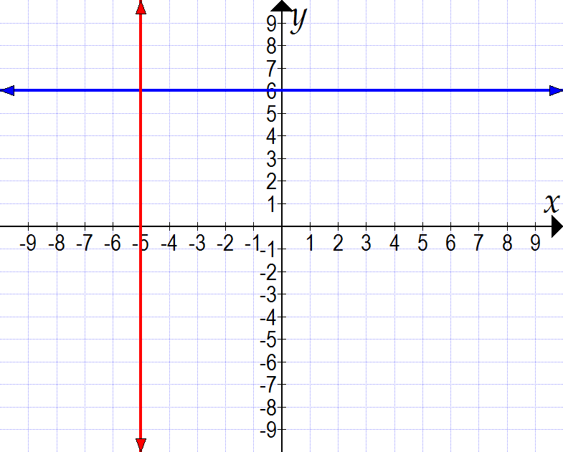

The equations of the lines are:

**A** *y* = -5 and *x* = 6 **B** *y* = -5 and *x* = 6 **C** *y* = 6 and *x* = -5 **D** *y* = -6 and *x* = -5

Multiple-choice results: ___ / 8

Short answer section

Question 9 3 marks [5.1]

Solve the equation 3(3*x* + 1) = 12. Check your answer by substitution.

Question 10 4 marks [5.2]

Let *D* represent Daniel’s age. Gillian’s age is three times Daniel’s age and the sum of their ages is 36. Write an equation to represent this information, and solve it to find Daniel’s and Gillian’s ages.

Question 11 3 marks [5.3]

Find the midpoint of the line segment joining (3, 7) and (7, 13).

Question 12 4 marks [5.4]

Use the equation *m* = -2*n* + 6 to:

(a) complete the table of values

|  |  |  |  |  |
| --- | --- | --- | --- | --- |
| n | 0 | 1 | 2 | 3 |
| m |  |  |  |  |

(b) plot the graph on the axes provided.

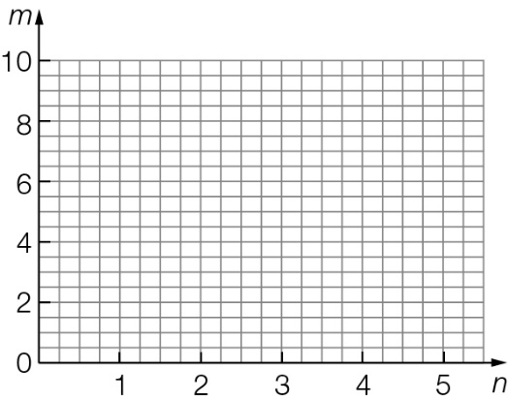

Question 13 3 marks [5.5]

Find the gradient of the line segment shown below.

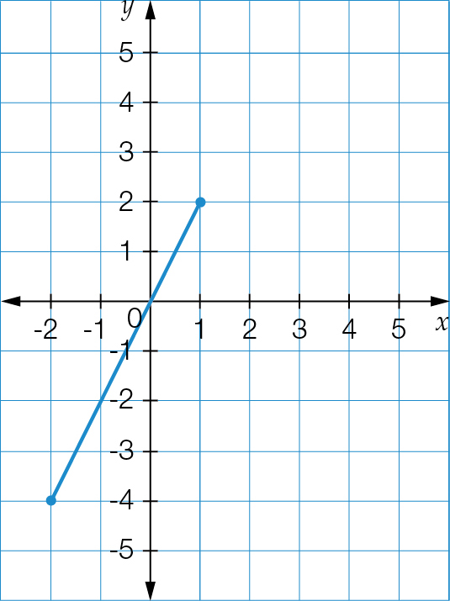

Question 14 4 marks [5.6]

Use the *y*-intercept and gradient method to sketch the graph of *y* = 2*x* − 6 on the axes provided.

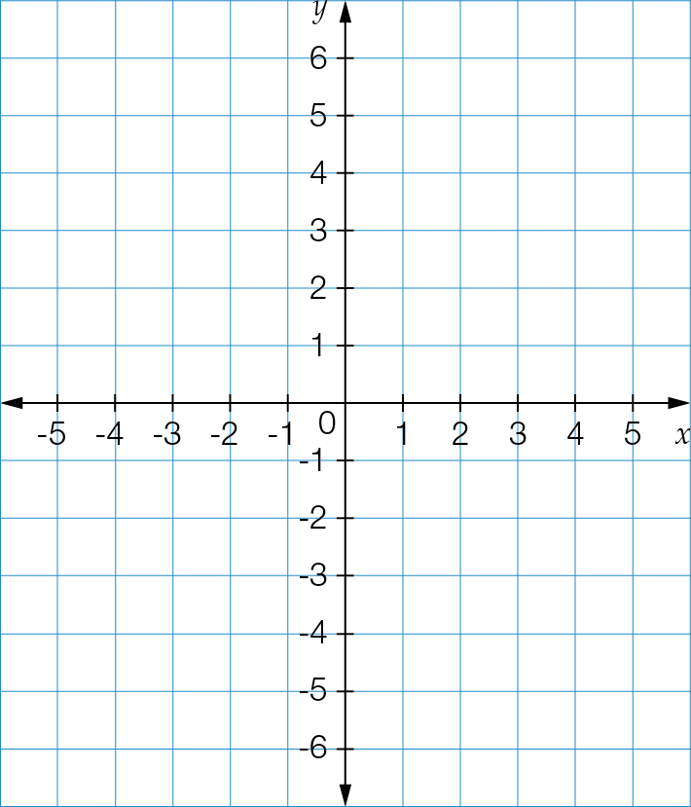

Question 15 4 marks [5.7]

Use the *x*- and *y*-intercept method to sketch the graph of 6*x* + 2*y* = 12 on the axes provided.

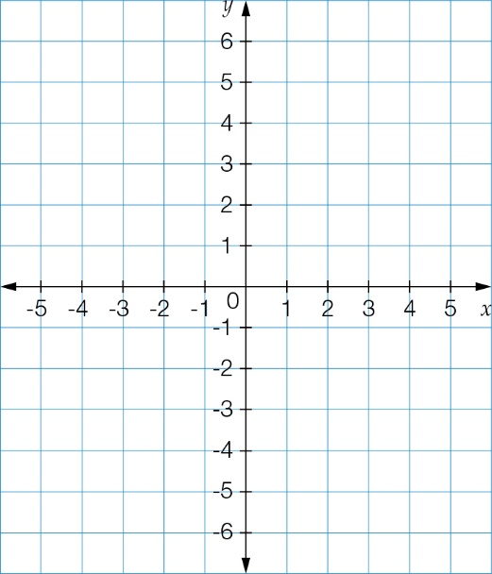

Question 16 2 marks [5.8]

On the axes provided, sketch the graph of *y* = 4, showing any intercepts with the axes.

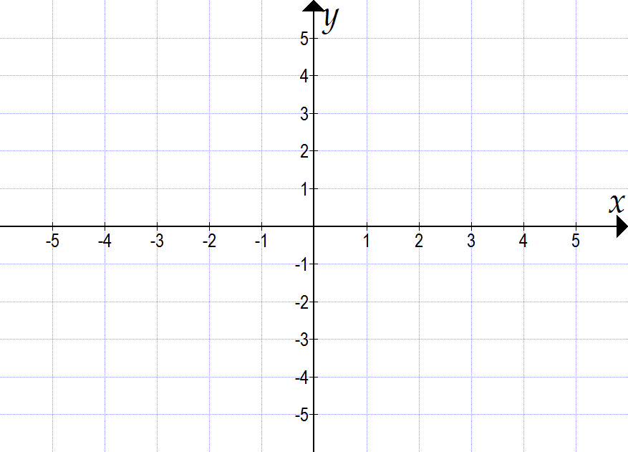

Short answer results: ___ / 27

Extended answer section

Question 17 12 marks [5.2, 5.4, 5.5]

Nerida starts from her home, shown as point *A* (the origin) on the graph in part **(a)** below, and rides her bicycle to point *B* at a constant speed for 3 minutes, covering a distance of 1200 metres.

(a) Represent the information on the distance−time graph below, and label point *B*.

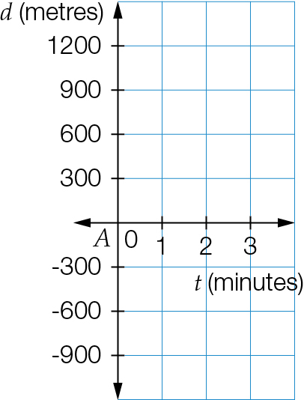

(b) Calculate the gradient of the graph, and give the units of the gradient.

(c) Write an equation connecting the distance travelled (*d* metres) to the time taken (*t* minutes).

(d) Use your equation in **(c)** above to calculate how long Nerida takes to travel 10 km.

(e) Complete the table below showing Nerida’s journey over a period of 5 minutes.

|  |  |  |  |  |  |  |
| --- | --- | --- | --- | --- | --- | --- |
| *t* | 0 | 1 | 2 | 3 | 4 | 5 |
| *d* |  |  |  |  |  |  |

Question 18 11 marks [5.3, 5.4, 5.6]

A quadrilateral *ABCD* has vertices at *A*(1, 2), *B*(6, 2), *C*(9, 6) and *D*(4, 6).

(a) Plot the points on the grid provided. Use a ruler to join the points in alphabetical order, to form the quadrilateral.

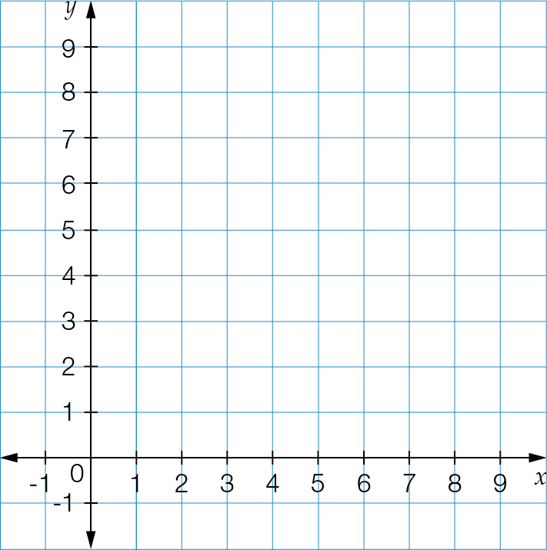

(b) Use the distance formula to find the length of side *AD*.

(c) Find the equation of the side *CD*.

(d) Use a ruler to draw a diagonal from *A* to *C*. Use the midpoint formula to find the midpoint of *AC*.

Extended answer results: ___ / 23

TOTAL test results: ___ / 58